**Enable and Disable**

**Developers Mode in MS Access 2010**

Created By: Eros Niko Cas Alvarez

Email Address: Eros_Niko_K_Alvarez@manulife.com

Date Created: September 09, 2016

**Purpose:** This enables and disables executing MS Access Projects as Developers Mode *(Executing it by SHIFT+ENTER)*

***NOTE: BACK UP YOUR MS ACCESS PROJECT BEFORE COMMITING CHANGES.***

**Methods:**

1. **Hide Navigation Pane** *(for confidentiality of objects)*
   1. Go to File > Options > Current Database
   2. Under Navigation > Untick Navigation Pane
2. **Encrypt VBA Code**
   1. Go to Visual Basic Mode (Alt +F11)
   2. Go to Tools > Project Properties
   3. Under Protection Tab:
      1. Tick Lock Project for viewing
      2. 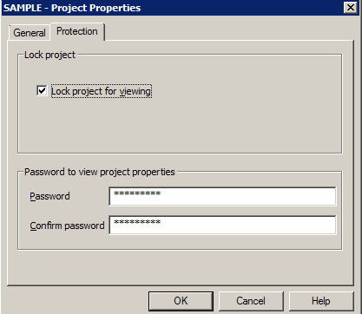Encrypt it with Password
3. **Import** **Module**
   1. Under Visual Basic Mode: Go to File> Import File and select Sys_Settings.bas

*Note: module is the responsible for enabling and disabling Developer’s mode to MS Access Project.*

1. **Customization**
   1. Open Default_Form as Design mode.
   2. Create 2 components. (I suggest Label component) one is to Enable Developer’s Mode and the other one is to Disable Developer’s Mode.
   3. Add events to those components.
      1. For Enable Dev Mode. Write this code:

*Sys_Settings.ap_EnableShift*

* + 1. For Disable Dev Mode. Write this code:

*Sys_Settings.ap_DisableShift*

***Note: Make sure that those components are not easy to be accessed by normal users.***

1. **Before Deployment**. **Disable** the Developer’s mode by clicking the component that has disabling method for developer’s mode. You can re-enable it by triggering the component that has enabling method for developer’s mode.